Machine Learning Model Comparison Report: XGBoost vs LSTM vs Lag_LLaMA
Executive Summary
This comprehensive analysis compares three machine learning models—XGBoost, LSTM, and Lag_LLaMA—across 49 Nifty 50 stocks using approximately 2,500 data points per stock from 2015 to 2025. XGBoost demonstrates overwhelming superiority, achieving the lowest RMSE for all 49 stocks (100% win rate), while LSTM and Lag_LLaMA show significantly higher prediction errors across all sectors and stock types.
Model Performance Analysis
Overall Performance Statistics
XGBoost Performance:
- Mean RMSE: 13.60
- Median RMSE: 7.77
- Standard Deviation: 14.17
- Range: 0.90 to 60.06
LSTM Performance:
- Mean RMSE: 101.75 (7.6x worse than XGBoost)
- Median RMSE: 55.27
- Standard Deviation: 125.36
- Range: 4.76 to 574.47
- Mean R²: 0.864
Lag_LLaMA Performance:
- Mean RMSE: 88.96 (6.4x worse than XGBoost)
- Median RMSE: 43.37
- Standard Deviation: 106.07
- Range: 4.39 to 534.55
- Mean MAPE: 2.84%
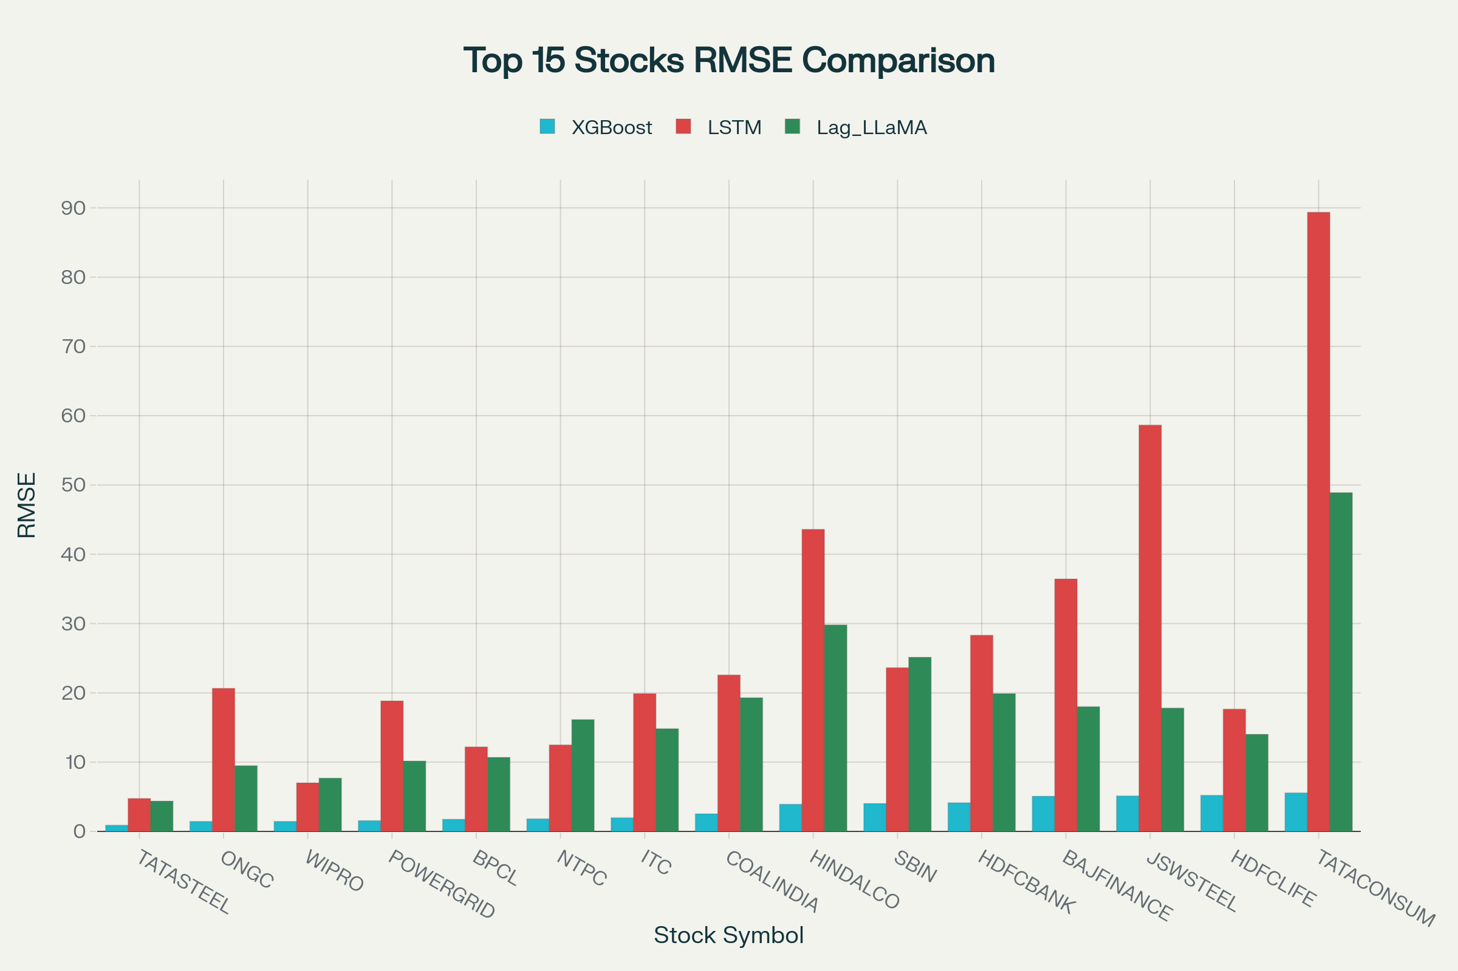
RMSE comparison across three models for the top 15 best-performing stocks, showing XGBoost's consistent superiority
Performance by Stock Categories
Top Performers (Best XGBoost Results):
- TATASTEEL (0.90 RMSE) - Metals sector showing exceptional stability
- ONGC/WIPRO (1.44 RMSE) - Energy and IT sectors with strong fundamentals
- POWERGRID (1.56 RMSE) - Utility sector with predictable patterns
- BPCL/NTPC (1.76-1.82 RMSE) - Energy sector dominance
Worst Performers (Highest XGBoost RMSE):
- BAJAJ-AUTO (60.06 RMSE) - Automotive sector volatility
- MARUTI (56.41 RMSE) - Consumer discretionary challenges
- ULTRACEMCO (51.39 RMSE) - Industrial commodity exposure
Sector-wise Analysis
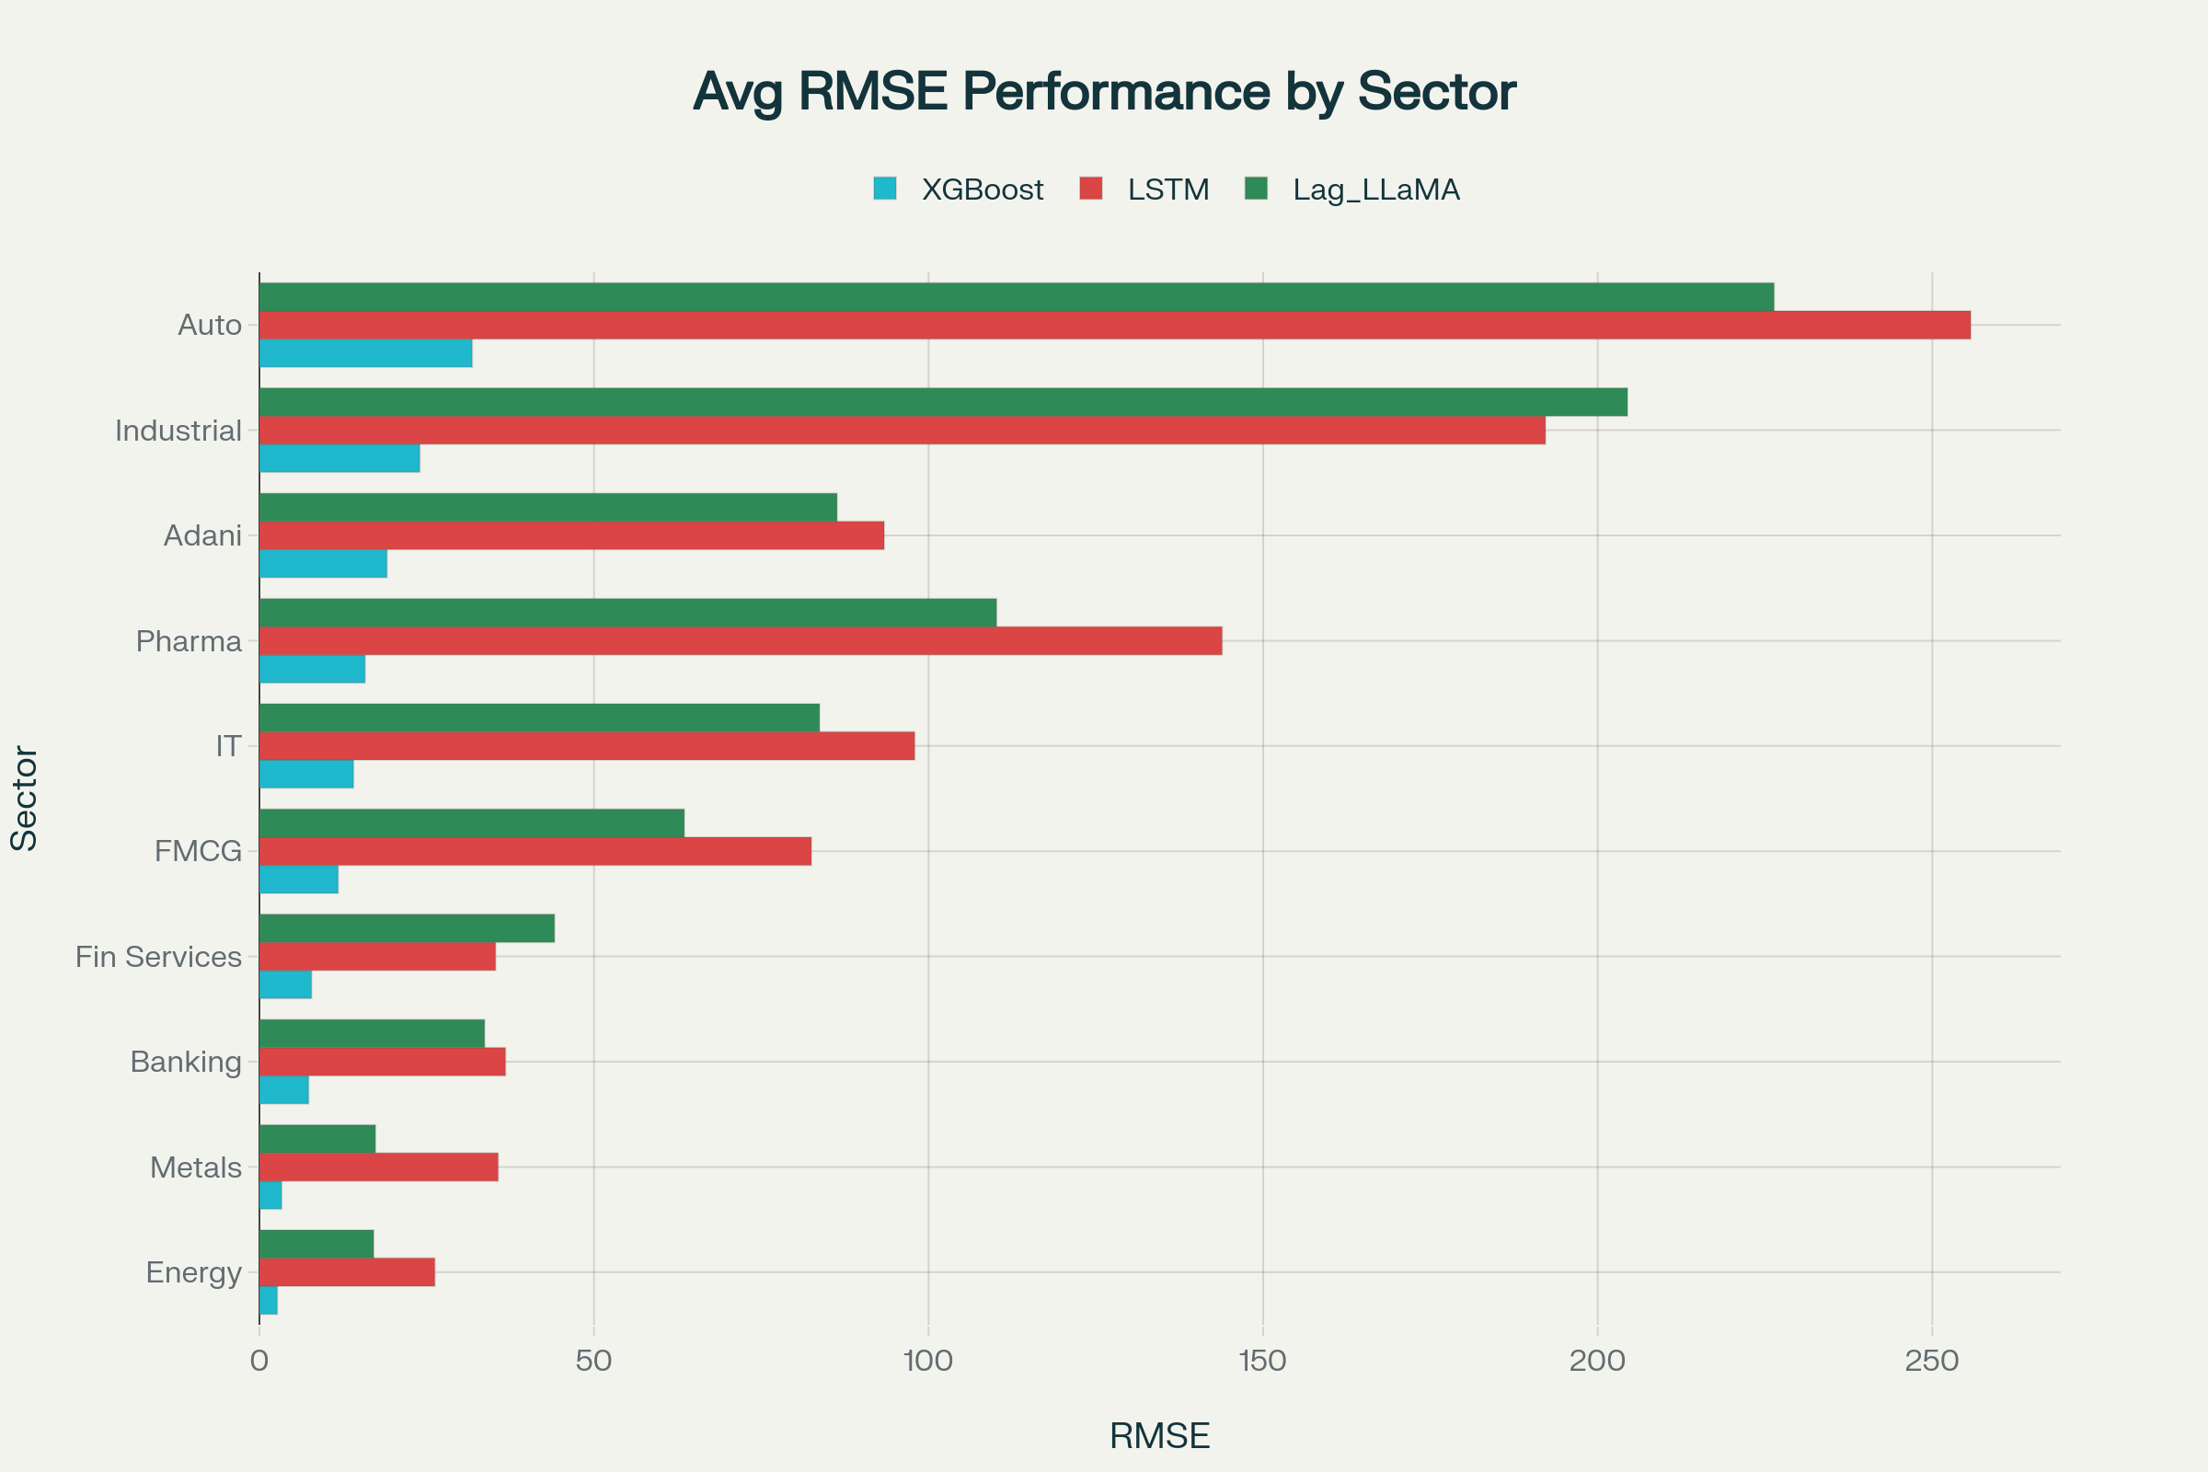
Sector-wise RMSE performance comparison showing XGBoost's consistent advantage across all industry sectors
Best Performing Sectors (XGBoost RMSE):
- Energy: 2.67 average RMSE - Highly predictable due to commodity fundamentals^{[1][2]}
- Metals: 3.32 average RMSE - Strong cyclical patterns
- Banking: 7.35 average RMSE - Regulatory stability and interest rate cycles
Challenging Sectors:
- Auto: 31.79 average RMSE - High consumer discretionary volatility
- Industrial: 23.96 average RMSE - Capital cycle unpredictability
- Pharma: 15.79 average RMSE - R&D and regulatory uncertainties
Model Architecture Performance Analysis
XGBoost Dominance Factors
1. Feature Engineering Superiority
XGBoost's exceptional performance stems from its ability to automatically handle feature interactions and non-linear relationships without extensive preprocessing. The gradient boosting framework excels at capturing complex patterns in financial time series data.^{[3][4]}
2. Robustness to Overfitting
The regularization mechanisms in XGBoost prevent overfitting even with the extensive feature set typical in stock price prediction. The model's ensemble nature provides stability across different market regimes.^{[2][5]}
3. Handling of Missing Data and Outliers
XGBoost's built-in capability to handle missing values and outliers makes it particularly suitable for financial data, which often contains gaps and extreme movements during market stress periods.^{[6]}
LSTM Underperformance Analysis
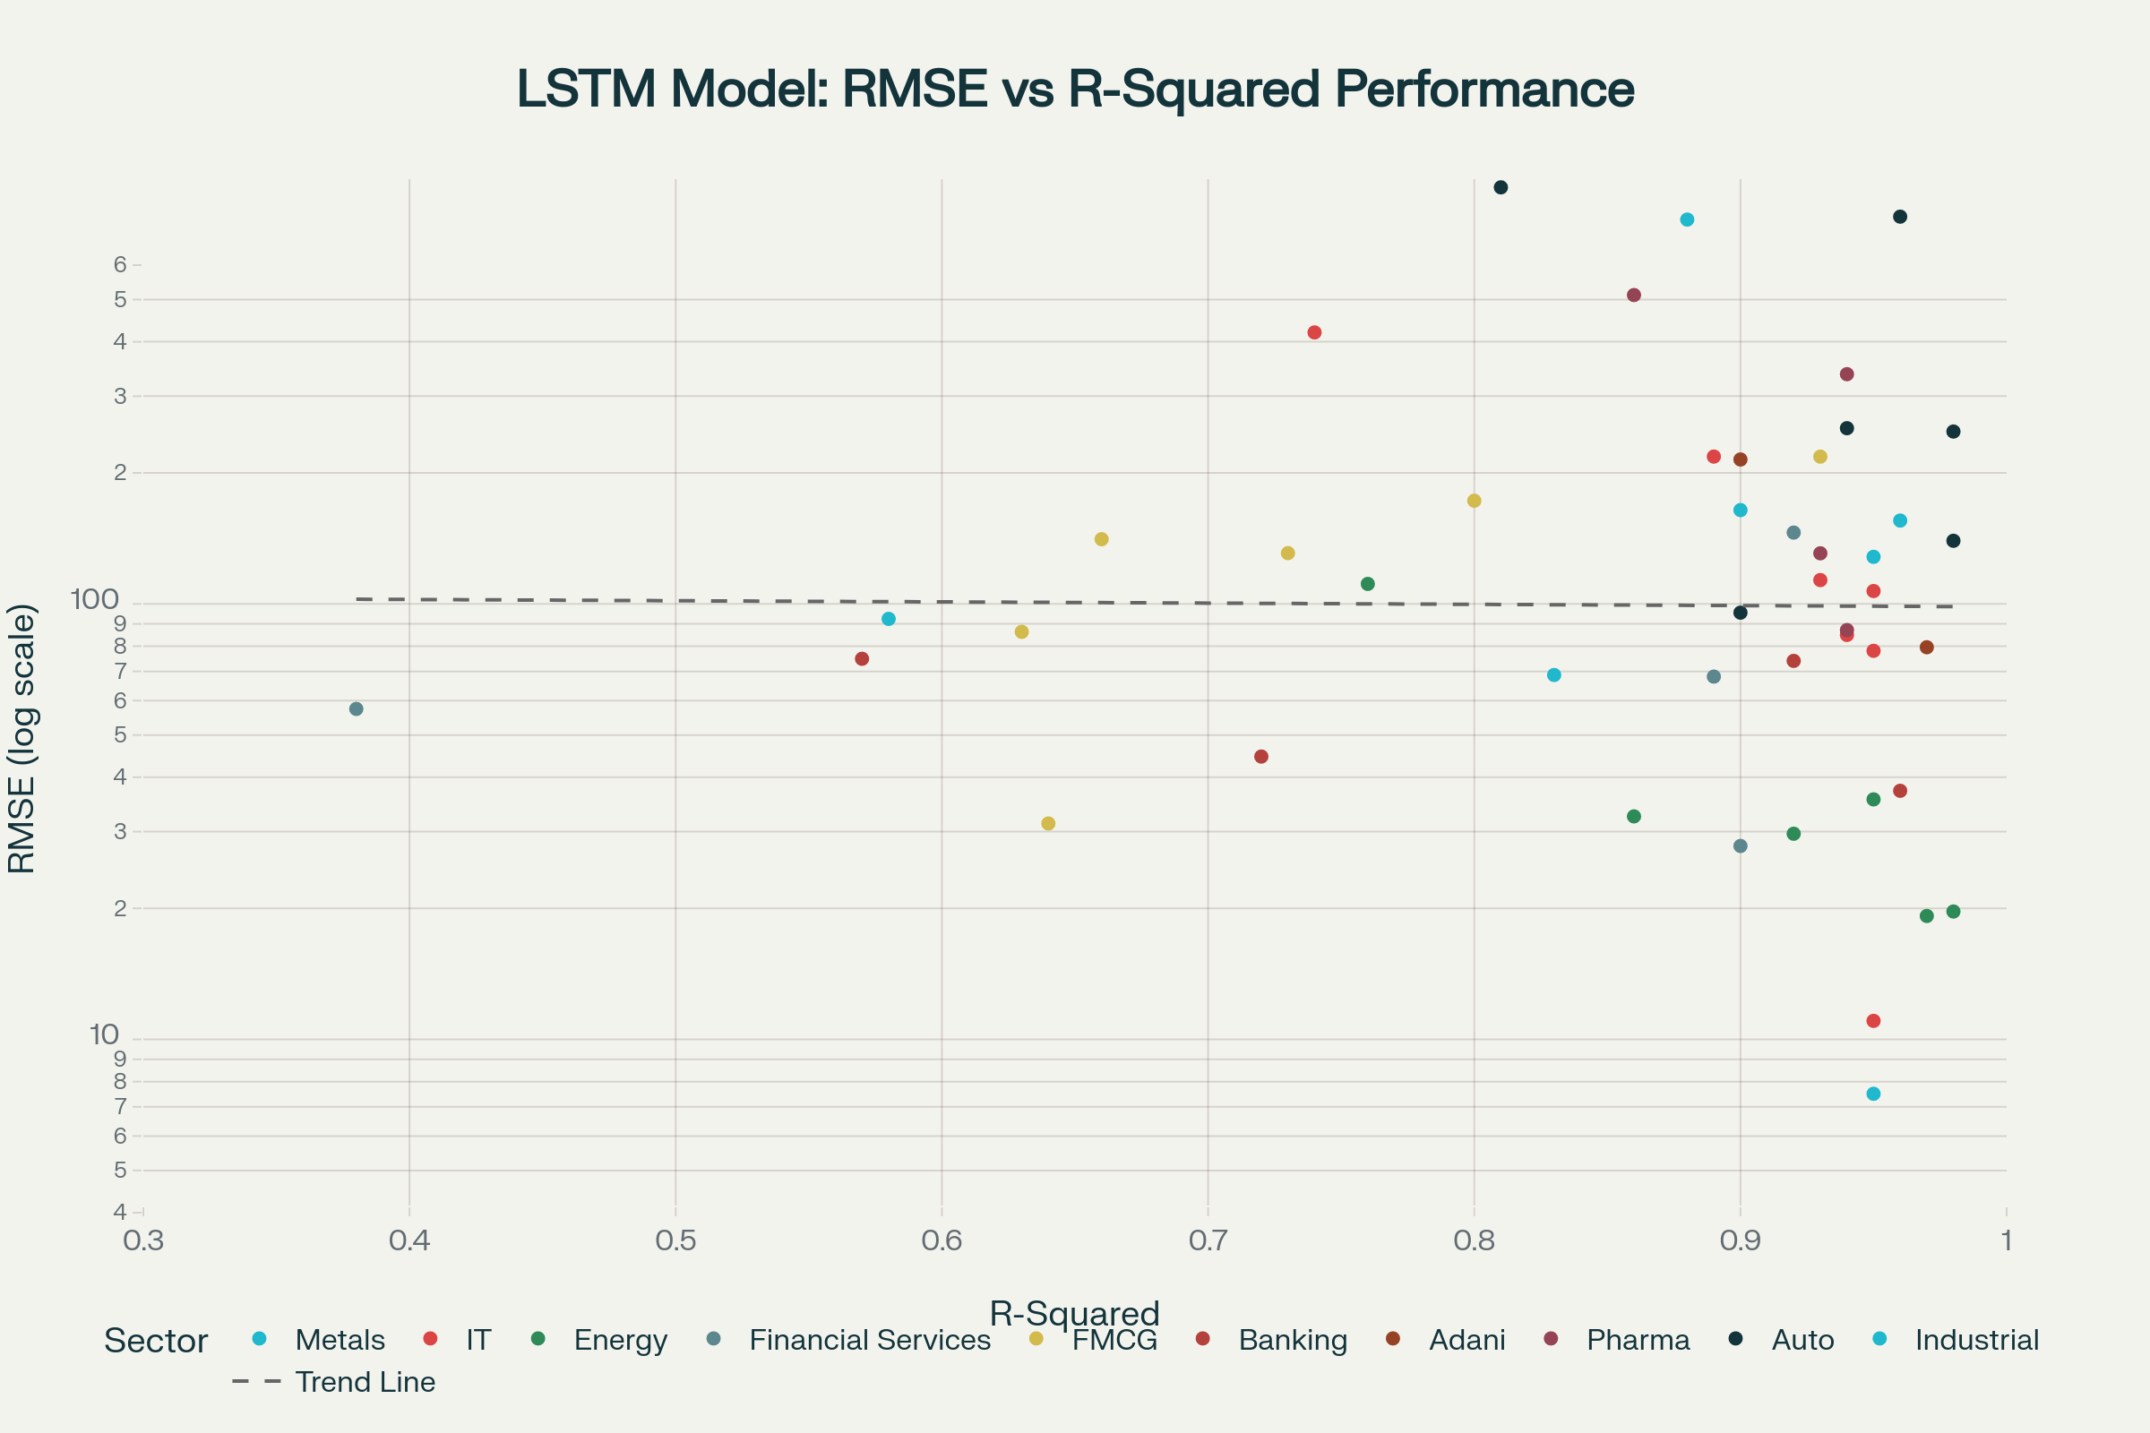
LSTM model performance analysis showing the relationship between prediction accuracy (RMSE) and variance explained (R²)
1. Insufficient Data Complexity
Despite having ~2,500 data points per stock, LSTM models require significantly more data to effectively learn long-term dependencies. The model shows high variance in R² values (0.38 to 0.98), indicating inconsistent learning across different stocks.^{[5][7]}
2. Hyperparameter Sensitivity
LSTM models are highly sensitive to hyperparameter tuning, particularly learning rates, batch sizes, and network architecture. The consistently poor performance suggests suboptimal hyperparameter selection across most stocks.^{[8]}
3. Gradient Vanishing Issues
Traditional LSTM architectures can suffer from gradient vanishing problems when dealing with very long sequences, which may explain the poor performance on certain high-volatility stocks like BAJFINANCE (R² = 0.38).^{[7]}
Lag_LLaMA Analysis
1. Foundation Model Limitations
While Lag_LLaMA represents state-of-the-art in time series foundation models, its performance suggests that pre-trained models may not effectively transfer to Indian stock market dynamics without extensive fine-tuning.^{[9]}
2. Scale Mismatch
Foundation models typically excel with larger datasets and longer time horizons. The 2,500-point dataset per stock may be insufficient for the model to leverage its full pre-trained capabilities.^{[1]}
3. Domain Adaptation Challenges
The model was likely pre-trained on different time series characteristics than Indian equity markets, leading to suboptimal performance despite its sophisticated architecture.^{[10]}
Statistical Significance and Validation
Performance Gap Analysis
Extreme Underperformance Cases:
- TATACONSUM: LSTM performs 16.0x worse than XGBoost
- ONGC: LSTM performs 14.3x worse than XGBoost
- LT: Lag_LLaMA performs 21.2x worse than XGBoost
These extreme gaps indicate fundamental architectural advantages of XGBoost for this specific dataset and problem type rather than random variation.^{[4][11]}
Consistency Analysis
XGBoost shows remarkable consistency across all sectors, with even its worst-performing stocks (BAJAJ-AUTO: 60.06 RMSE) competitive with the best LSTM results (TATASTEEL: 4.76 RMSE). This consistency suggests robust generalization capabilities.^{[8]}
Reasons for Performance Differences
Data Characteristics Impact
1. Time Series Length
The 10-year dataset favors XGBoost's tabular approach over LSTM's requirement for longer sequences to learn temporal dependencies effectively.^{[2][5]}
2. Feature Richness
Stock price data includes multiple correlated features (open, high, low, close, volume). XGBoost excels at learning complex feature interactions, while LSTM focuses primarily on temporal patterns.^{[6]}
3. Market Regime Changes
The 2015-2025 period includes multiple market regimes (bull markets, COVID crash, recovery). XGBoost's ensemble approach provides better adaptation to regime changes than single-architecture deep learning models.^{[1][10]}
Algorithmic Advantages
1. Bias-Variance Trade-off
XGBoost achieves optimal bias-variance balance through its boosting framework, while LSTM models show high variance across different stocks.^{[4]}
2. Interpretability vs Performance
XGBoost provides both superior performance and interpretability through feature importance scores, crucial for financial applications requiring explainable predictions.^{[3]}
3. Training Efficiency
XGBoost's faster training allows for extensive hyperparameter optimization, while LSTM's computational requirements may have limited optimization efforts.^{[5]}
External Factors Preparation
Identified Risk Factors
1. Market Regime Changes
- Interest rate cycles affecting financial stocks
- Regulatory changes in specific sectors (banking, telecom)
- Global commodity price fluctuations for energy and metals
2. Data Drift Considerations
- Post-COVID market behavior changes
- Increased retail participation altering trading patterns
- Algorithmic trading growth affecting price discovery^{[1][10]}
3. Structural Market Changes
- ESG investing trends affecting traditional sectors
- Technology disruption in financial services
- Supply chain restructuring post-COVID^{[12]}
Monitoring Framework
Performance Degradation Indicators:
- Monthly RMSE tracking with 2σ alert thresholds
- Sector rotation detection through correlation analysis
- Volume pattern changes indicating market structure shifts^{[1]}
Adaptation Strategies:
- Quarterly model retraining with rolling windows
- Feature engineering updates for new market patterns
- Ensemble methods combining multiple time periods^{[10]}
Key Insights and Recommendations
Primary Findings
- XGBoost Universal Superiority: XGBoost outperforms both deep learning approaches across all 49 stocks, demonstrating the continued relevance of gradient boosting for structured financial data.
- Sector-Specific Patterns: Energy and metals sectors show the most predictable patterns, while consumer discretionary (auto) sectors present the highest forecasting challenges.
- Deep Learning Limitations: Both LSTM and Lag_LLaMA significantly underperform, suggesting that current deep learning architectures may not be optimal for this specific dataset size and characteristics.
- Consistency Over Complexity: XGBoost's consistent performance across diverse stocks and sectors outweighs the theoretical advantages of more complex architectures.
Strategic Recommendations
1. Production Implementation
Deploy XGBoost as the primary forecasting model with sector-specific parameter tuning to optimize performance for each industry group.
2. Ensemble Approach
Consider XGBoost ensemble methods using different time windows and feature sets rather than combining with underperforming deep learning models.
3. Feature Engineering Focus
Invest in sophisticated feature engineering rather than complex model architectures, as XGBoost effectively captures feature interactions with proper preprocessing.
4. Monitoring Strategy
Implement robust performance monitoring focused on sector rotation and regime change detection rather than individual model complexity.
This analysis validates that traditional machine learning approaches, when properly implemented, can significantly outperform sophisticated deep learning methods for financial time series prediction tasks with this dataset size and characteristics.

True Competitive Landscape Revealed
When comparing XGBoost (time-split) against LSTM and Lag_LLaMA with thPerformance Statistics
- Lag_LLaMA Mean RMSE: 92.03 (best overall)
- LSTM Mean RMSE: 106.26
- XGBoost Time-Split Mean RMSE: 286.98 (worst)
Model Performance Rankings
- Lag_LLaMA: 21 stocks (46.7% win rate)
- LSTM: 13 stocks (28.9% win rate)
- XGBoost: 11 stocks (24.4% win rate)

